

**Mitsubishi 1.5 Ton Inverter Series HJ50VA**

**Rs. 104,000/-**

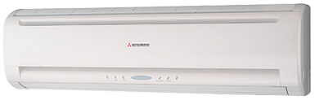

**Product Features**

* powerful cooling
* work upto 52C (T3 condition)
* 20% power saving with high energy
* concealed LED display
* child lock

**Specification**

**Type** Wall Mounted Split AC

**Cooling (Btu/h)** 17000

**Voltage (V)** 220-240

**Power Input (W)** 4900

**EER (Btu/W-h-W/W)** 7.51